CHAPTER 13

Project
Scheduling:
PERT/CPM

KEY CONCEPTS

ILLUSTRATED ANSWERED
CONCEPT PROBLEMS PROBLEMS

Construction of PERT Networks 1,2 6,8,12,13

PERT Analysis with Certain Times 1 6,7,9

PERT Analysis with Uncertain Times 2,4 8,10,11

Activity Earliest/Latest Times 1,2,5 7,9,14

Time/Cost Analysis 3,4 9-13

LP Formulation for Crashing 3 12,13

REVIEW

1. PERT (Program Evaluation Review Technique) is used to plan the scheduling of individual activities that make up a project.

2. A PERT network can be constructed to model the precedence of the activities. The nodes of the network represent the activities.

3. PERT can be used to determine the earliest/latest start and finish times for each activity, the entire project completion time and the slack time for each activity. (See algorithm at the end of the Review.)

4. A critical path for the network is a path consisting of activities with zero slack.

5. In the three-time estimate approach, the time to complete an activity is assumed to follow a Beta distribution. Its mean is t = (a + 4m + b)/6, and its variance is σ2 = ((b-a)/6)2. Here a = the optimistic completion time estimate, b = the pessimistic completion time estimate, and m = the most likely completion time estimate.

6. In the three-time estimate approach, the critical path is determined as if the mean times for the activities were fixed times. The overall project completion time is assumed to have a normal distribution with mean equal to the sum of the means along the critical path and variance equal to the sum of the variances along the critical path.

7. In the CPM (Critical Path Method) approach to project scheduling, it is assumed that the normal time to complete an activity, tj, which can be met at a normal cost, cj, can be crashed to a reduced time, tj', under maximum crashing for an increased cost, cj'.

8. Using CPM, activity j's maximum time reduction, Mj, may be calculated by: Mj = tj - tj'. It is assumed that its cost per unit reduction, Kj, is linear and can be calculated by:
Kj = (cj' - cj)/Mj.

- Linear programming may be used to solve a CPM problem to minimize the crashing costs needed to complete a project within a specified time limit.

PERT/CPM CRITICAL PATH PROCEDURE

Step 1: Develop a list of the activities that make up the project.

Step 2: Determine the immediate predecessors for each activity in the project.

Step 3: Estimate the completion time for each activity.

Step 4: Draw a project network depicting the activities (on nodes) and immediate predecessors listed in Steps 1 and 2.

Step 5: Use the project network and the activity time estimates to determine the earliest start and the earliest finish time for each activity by making a forward pass through the network. The earliest finish time for the last activity in the project identifies the total time required to complete the project.

Step 6: Use the project completion time identified in Step 5 as the latest finish time for the last activity and make a backward pass through the network to identify the latest start and finish time for each activity.

Step 7: Use the difference between the latest start time and the earliest start time for each activity to determine the slack for the activity.

Step 8: Find the activities with zero slack; these are the critical activities.

Step 9: Use the information from Steps 5 and 6 to develop the activity schedule for the project.

FLOW CHART FOR
COMPUTING PROJECT COMPLETION TIME PROBABILITY

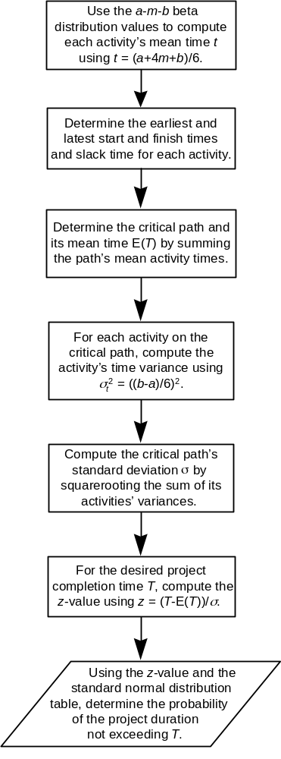

FLOW CHART FOR
PROJECT CRASHING

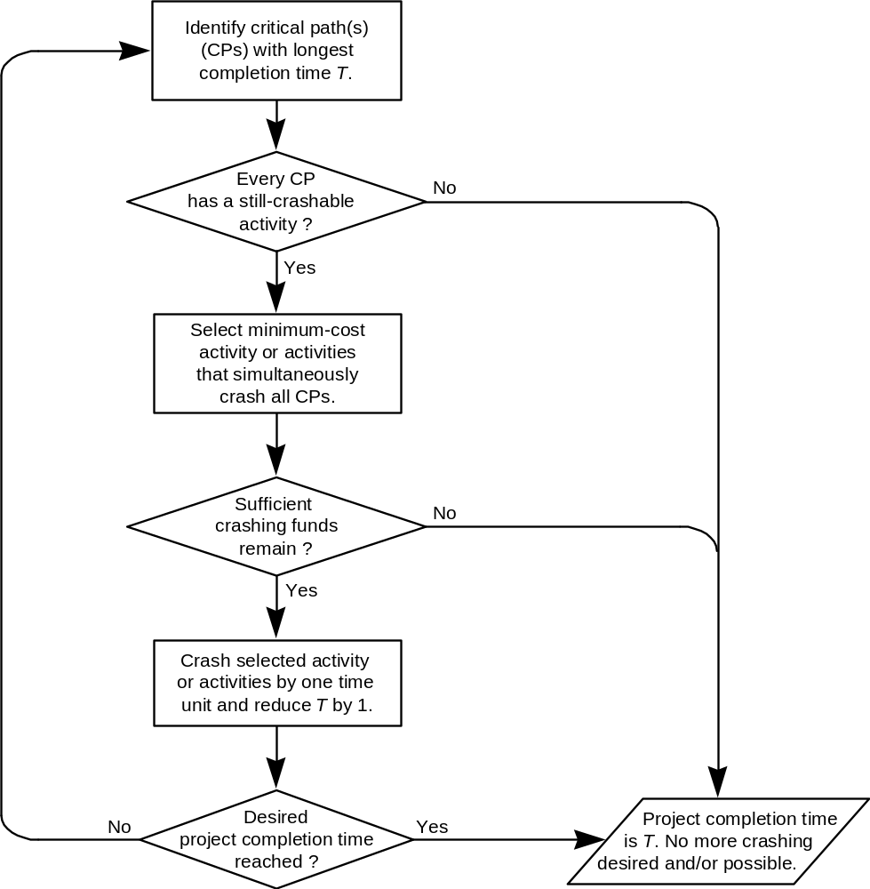

ILLUSTRATED PROBLEMS

PROBLEM 1

Kraft's Kustom Kars is in the business of producing custom automobile assemblies. In particular, Kraft operates a shop that builds and assembles the body and frame of the cars.
Kraft's operations begin with the processing of initial paperwork. This must be done before any other operations are commenced. Once the paperwork has been completed, the body of the car can be built in Room A and the frame of the car can be built in Room B. When the body is built, it is transferred to Room C for finishing work. Similarly, when the frame is built, it is transferred to Room D for finishing work.
When both are built, although not necessarily finished, the final paperwork can be completed. When both the body and frame are finished, they are transported to the assembly Room E, where the body is mounted to the frame.
In the frame building room, Room B, certain chemicals are used which must be completely eliminated by a thorough washdown to prevent gaseous fumes from becoming a health hazard. The project is considered complete when the final paperwork has been completed, the body has been mounted to the frame, and Room B has been completely washed down.
The table below gives the expected completion times in hours for each activity of the project.

Activity Description Completion Time
A Initial Paperwork 3
B Build Body 3
C Build Frame 2
D Finish Body 3
E Finish Frame 7
F Final Paperwork 3
G Mount Body to Frame 6
H Room B Washdown 2

a) Draw the PERT network that corresponds to this problem.

b) Find the earliest and latest start and finish times for each activity of the project. How long should the project take?

c) Which activities must not be delayed if the project is to be completed in the time calculated in part (b)?

d) Suppose the body finish operation (D) were delayed four hours. By how much would the entire project be delayed?

SOLUTION 1

Before constructing the PERT network, summarize in the following table the immediate predecessor activities for each activity.

Immediate Completion
Activity Predecessors Times (Hr.)
A -- 3
B A 3
C A 2
D B 3
E C 7
F B,C 3
G D,E 6
H C 2

To construct a PERT network, there must be a node for each activity. An activity’s immediate predecessors are the nodes that immediately precede it.

The result is:

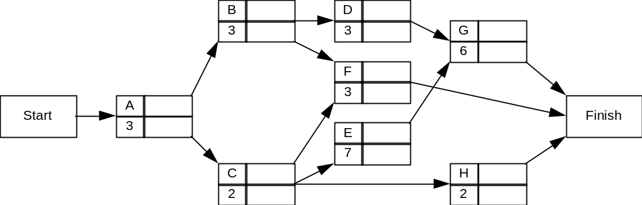

b) The earliest start time (ES) for activity A 0. Then the earliest finish time (EF) for an activity is given by: EF = ES + (completion time). Then ES for an activity = max (EF for all immediately preceding activities).

The forward pass to calculate ES and EF:

Earliest Earliest
Activity Start (ES) Finish(EF)
A 0 0 + 3 = 3
B 3 3 + 3 = 6
C 3 3 + 2 = 5
D 6 6 + 3 = 9
E 5 5 + 7 = 12
H 5 5 + 2 = 7
F MAX(5,6) = 6 6 + 3 = 9
G MAX(9,12) = 12 12 + 6 = 18
The max(EF of the activities immediately preceding the Finish node ) = 18, so the completion time of the project is 18.

The backward pass to calculate LF and LS:

Latest Latest
Activity Finish (LF) Start (LS)
H 18 18 - 2 = 16
G 18 18 - 6 = 12
F 18 18 - 3 = 15
E 12 12 - 7 = 5
D 12 12 - 3 = 9
C MIN(15,5,16) = 5 5 - 2 = 3
B MIN(9,15) = 9 9 - 3 = 6
A MIN(6,3) = 3 3 - 3 = 0

This gives the completed network below.

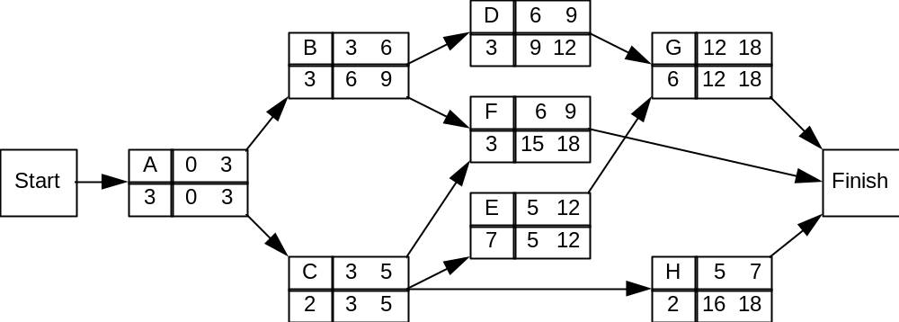

The slack time for each activity (LS - ES) is summarized below:

Activity ES EF LS LF Slack
A 0 3 0 3 0
B 3 6 6 9 3
C 3 5 3 5 0
D 6 9 9 12 3
E 5 12 5 12 0
F 6 9 15 18 9
G 12 18 12 18 0
H 5 7 16 18 11

NOTE: One way to partially check the accuracy of your activity earliest/latest time calculations is to compute every activity's slack two ways: Slack = (LS - ES) = (LF - EF) If the preceding is not true, you have an error! Also, the number of different values in your slack column should not exceed (but does not have to equal) the number of paths in the project network.

c) Activities A, C, E, G have 0 slack times -- they form the critical path.

d) Activity D has a slack of 3. Hence a 4 hour delay in D would delay the entire project
4 - 3 = 1 hour.

PROBLEM 2

Consider the following project:

Activity | Immediate  Predecessors | Optimistic  Time (Hr.) | Most Probable  Time (Hr.) | Pessimistic  Time (Hr.)
A | -- | 4 | 6 | 8
B | -- | 1 | 4.5 | 5
C | A | 3 | 3 | 3
D | A | 4 | 5 | 6
E | A | 0.5 | 1 | 1.5
F | B,C | 3 | 4 | 5
G | B,C | 1 | 1.5 | 5
H | E,F | 5 | 6 | 7
I | E,F | 2 | 5 | 8
J | D,H | 2.5 | 2.75 | 4.5
K | G,I | 3 | 5 | 7

a) Construct the PERT network for this problem.

b) Solve for the expected earliest and latest start and finish times for each activity.

c) Identify the critical path and give the estimated project completion time.

d) What is the probability the project will be completed within one day (24 hours)?

SOLUTION 2

a) Nodes are needed for the start node, the finish node, and all of the activities.

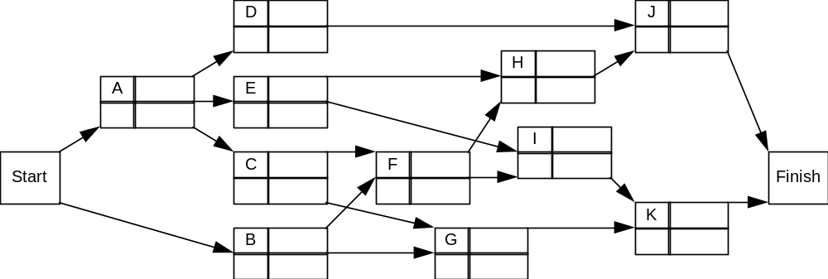

b) Calculate the expected times, t, and variances, σ2, for each activity.

t = (a + 4m + b)/6 σ2 = ((b-a)/6)2

Activity Expected Time Variance
A 6 4/9
B 4 4/9
C 3 0
D 5 1/9
E 1 1/36
F 4 1/9
G 2 4/9
H 6 1/9
I 5 1
J 3 1/9
K 5 4/9

Thus, using the algorithm illustrated in problem 1, we have:

Activity ES EF LS LF Slack
A 0 6 0 6 0
B 0 4 5 9 5
C 6 9 6 9 0
D 6 11 15 20 9
E 6 7 12 13 6
F 9 13 9 13 0
G 9 11 16 18 7
H 13 19 14 20 1
I 13 18 13 18 0
J 19 22 20 23 1
K 18 23 18 23 0
c) The critical path is the path of 0 slack = A-C-F-I-K. The estimated project completion time is the Max EF of the activities immediately preceding the Finish node = 23.

d) z = (24 - 23)/σ. Here, σ2 = σ2A + σ2C + σ2F + σ2I + σ2K

= 4/9 + 0 + 1/9 + 1 + 4/9 = 2.

Hence, σ = 1.414. Thus z = (24-23)/1.414 = .71. From appendix C,

P(z < .71) = .5 + .2612 = .7612.

PROBLEM 3

National Business Machines (NBM) has just developed a new microcomputer it plans to put into full scale production in a few months. The table and the PERT network below show the precedence relations and give the activity times and costs under normal operations and maximum crashing for a daily (22-hour) production of 1000 microcomputers at its local plant.
NBM wants to know the minimum cost of producing the 1000 microcomputers within the 22-hour period. Formulate and solve a linear program that will yield this information.

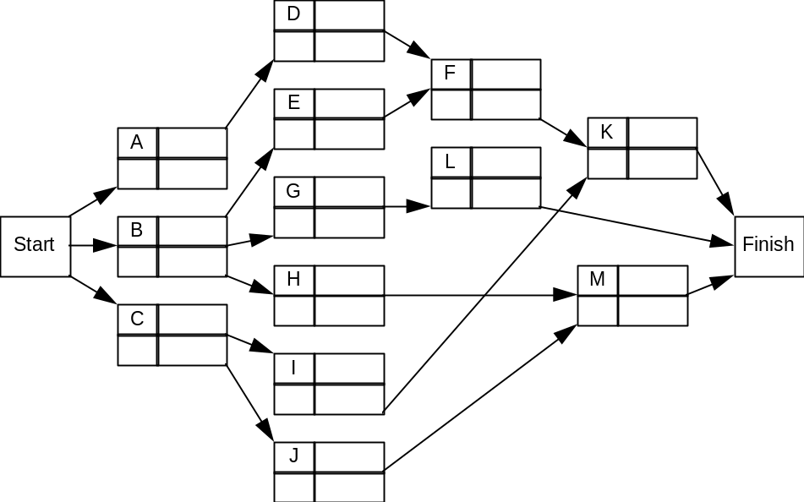

Normal Normal Crash Crash
Activity Time (hr) Cost Time (hr) Cost
A 2 $2,000 1.5 $3,000
B 4 3,000 3 3,500
C 1 1,500 1 1,500
D 4 5,300 2.5 8,000
E 6 5,400 5 7,000
F 10 6,000 8 9,000
G 8 4,800 5 9,900
H 2 2,800 1 2,900
I 5 4,500 4 5,000
J 12 6,000 6 9,600
K 7 7,000 4 9,700
L 11 8,800 9 9,200
M 4 1,000 1 7,000

SOLUTION 3

First prepare a chart giving maximum crashing,

M = (Normal Time) - (Time Under Maximum Crashing)

and the marginal cost per hour for crashing,

K = ([Cost Under Maximum Crashing] - [Normal Cost])/M

Activity M K
A 0.5 2000
B 1 500
C 0 0
D 1.5 1800
E 1 1600
F 2 1500
G 3 1700
H 1 100
I 1 500
J) 6 600
K 3 900
L 2 200
M 3 2000

Let x_{A}= earliest finish time for Activity A, and y_{A} = amount of time Activity A is crashed.

The linear program must minimize the total extra cost:

MIN 2000yA + 500yB + 1800yD + 1600yE + 1500yF + 1700yG
+ 100yH + 500yI + 600yJ + 900yK + 200yL + 2000yM

Subject to:
- The project must be completed within 22 hours: xK < 22, xL < 22, xM < 22

(2) The amount an activity is crashed cannot exceed its maximum crashing:

yA < 0.5
yB < 1
yD < 1.5
yE < 1
yF < 2
yG < 3
yH < 1
yI < 1
yJ < 6
yK < 3
yL < 2
yM < 3

(3) For each activity:
(Earliest Finish Time) > (Earliest Finish Time of Preceding Activity)
+ [(Normal Activity Time) - (Amount of Time the Activity is crashed)]

xA > 0 + (2 – yA) or xA + yA > 2
xB > 0 + (4 – yB) or xB + yB > 4
xC > 0 + (1 – 0) or xC > 1

xD > xA + (4 – yD) or xD + yD – xA > 4
xE > xB + (6 – yE) or xE + yE – xB > 6
xG > xB + (8 – yG) or xG + yG – xB > 8
xH > xB + (2 – yH) or xH + yH – xB > 2
xI > xC + (5 – yI) or xI + yI – xC > 5
xJ > xC + (12 – yJ) or xJ + yJ – xC > 12

xF > xD + (10 – yF) or xF + yF – xD > 10
xF > xE + (10 – yF) or xF + yF – xE > 10
xL > xG + (11 – yL) or xL + yL – xG > 11

xK > xF + (7 – yK) or xK + yK – xF > 7
xK > xI + (7 – yK) or xK + yK – xI > 7
xM > xH + (4 – yM) or xM + yM – xH > 4
xM > xJ + (4 – yM) or xM + yM – xJ > 4

(4) Non-negativity of the variables:

xi > 0 for I = A, B, C, …., M
yj > 0 for j = A, B, D, …., M

The Management Scientist provided the following solution output:

Objective Function Value = 4700.000

Variable Value Reduced Costs
XA 5.000 0.000
XB 3.000 0.000
XC 1.000 0.000
XD 9.000 0.000
XE 9.000 0.000
XF 18.000 0.000
XG 11.000 0.000
XH 13.000 0.000
XI 18.000 0.000
XJ 13.000 0.000
XK 22.000 0.000
XL 22.000 0.000
XM 17.000 0.000
YA 0.000 2000.000
YB 1.000 0.000
YD 0.000 1800.000
YE 0.000 100.000
YF 1.000 0.000
YG 0.000 1500.000
YH 0.000 100.000
YI 0.000 500.000
YJ 0.000 600.000
YK 3.000 0.000
YL 0.000 0.000
YM 0.000 2000.000

Summary:

Crash activity B one hour, activity F one hour, and activity K three hours. The 1000-unit daily production output will be achieved in 22 hours at a crashing cost of $4700.

PROBLEM 4

Given the following PERT network for Gus's Painters:

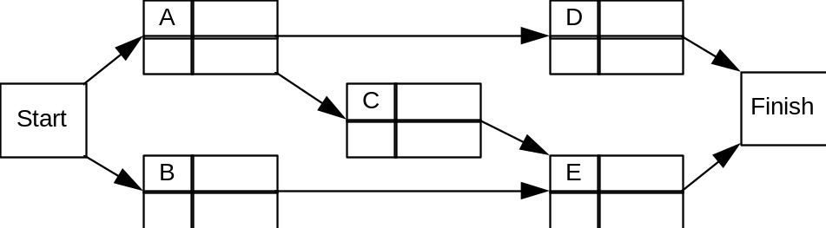

The following means and standard deviations were calculated for the activities:

Activity t σ
A 6 2
B 3 1
C 6 1
D 15 2
E 12 2

There is a $100,000 bonus for completing the project in 26 weeks. Currently activity E is assigned to Wilson Brothers. Gus has the option of hiring Jones Inc. for activity E. Their expected completion time for activity E is 8 weeks (with a standard deviation of 2), but they will cost Gus $15,000 more to do E than Wilson Brothers. Should Gus hire Jones?

SOLUTION 4

Analysis using Wilson Brothers to do E:

Activity ES EF LS LF
A 0 6 0 6
B 0 3 9 12
C 6 12 6 12
D 6 21 9 21
E 12 24 12 24

Hence the critical path is A - C - E and the overall expected project completion time is 24.

The variance of the critical path is:

σ2 = σ2A + σ2C + σ2E = (2)2 + (1)2 + (2)2 = 9. Thus σ = 3.

To find the probability of completing the project in 26 weeks, calculate,

z = (26 - 24)/3 = .67.

Thus the probability of finishing in 26 weeks is P(z < .67). From Appendix C, the table gives the P(0 < z < .67) = .2486. Therefore the probability of completing the project within 26 weeks is .5 + .2486 = .7486.

Thus the expected bonus using Wilson Brothers to do E is:

(.7486)(100,000) + (.2514)(0) = $74,860.

Analysis using Jones, Inc. to do E:

Activity ES EF LS LF
A 0 6 0 6
B 0 3 10 13
C 6 12 7 13
D 6 21 6 21
E 12 20 13 21

Hence the critical path is A - D and the overall expected project completion time is 21. The variance of the critical path is:

σ2 = σ2A + σ2D = (2)2 + (2)2 = 8. Thus σ = 2.828.

To find the probability of completing the project in 26 weeks, calculate,

z = (26 - 21)/2.828 = 1.77.

Thus the probability of finishing in 26 weeks is P(z < 1.77). From Appendix C, the table gives the P(0 < z < 1.77) = .4616. Therefore the probability of completing the project within 26 weeks is .5 + .4616 = .9616.

Thus the expected bonus using Jones, Inc. to do E is:

(.9616)(100,000) + (.0384)(0) = $96,160.

Decision:

The difference in expected returns between the two firms is: $96,160 - $74,860 = $21,300. Since this is greater than the $15,000 cost to hire Jones, Inc., Gus should hire Jones, Inc.

PROBLEM 5

For the project represented below, determine the earliest and latest start and finish times for each activity as well as the expected overall completion time.

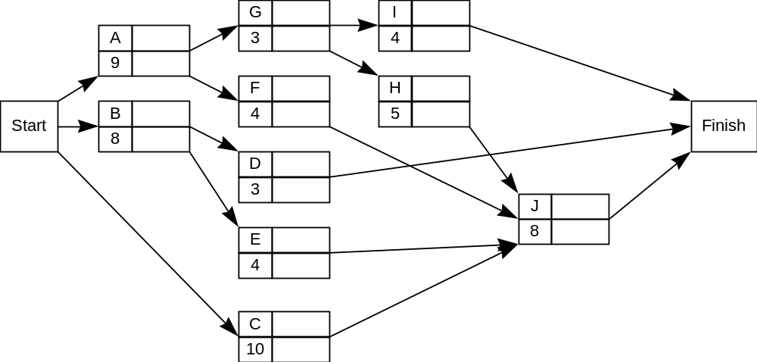

SOLUTION 5

a) Solving the PERT network for the ES, EF, LS, LF, and slack times by the method illustrated in problem 1, we can summarize:

Activity ES EF LS LF Slack
A 0 9 0 9 0
B 0 8 5 13 5
C 0 10 7 17 7
D 8 11 22 25 14
E 8 12 13 17 5
F 9 13 13 17 4
G 9 12 9 12 0
H 12 17 12 17 0
I 12 16 21 25 9
J 17 25 17 25 0

The overall project completion time is 25 weeks.

ANSWERED PROBLEMS

PROBLEM 6

Consider a project that has been modeled as follows:

Activity Immediate Predecessors Completion Time (hr.)
A --- 7
B --- 10
C A 4
D A 30
E A 7
F B,C 12
G B,C 15
H E,F 11
I E,F 25
J E,F 6
K D,H 21
L G,J 25

a) Draw the PERT network for this project and determine project's expected completion time and its critical path.

NOTE: If you are only interested in identifying the critical path and expected project completion time, there might be an easier approach than determining every activity's earliest start and finish times. List (if there are not too many) every path in the network and, for each one, sum the expected times of the activities on that path. You are looking for the path with the largest sum.

b) Can activities E and G be performed simultaneously without delaying the minimum project completion time?

c) Can one person perform A, G, and I without delaying the project?

d) By how much can activities G and L be delayed without delaying the entire project?

e) How much would the project be delayed if activity G was delayed by 7 hours and activity L was delayed by 4 hours? Explain.
PROBLEM 7

Given the following PERT network of tasks with completion times in hours for scheduling interns in a hospital:

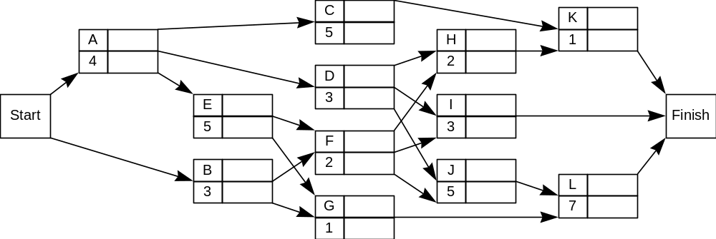

a) If interns start at midnight (00:00), determine each activity’s ES, EF, LS, LF, and slack.

b) What is the critical path and project completion time?

c) If an intern can do any job and works a 24-hour shift, show that two interns can complete all the jobs. (Hint: One intern is assigned the critical path jobs.)

PROBLEM 8

A project consists of five activities. Naturally the paint mixing precedes the painting activities. Also, both ceiling painting and floor sanding must be done prior to floor buffing.

Optimistic Most Probable Pessimistic
Activity Time (hr.) Time (hr.) Time (hr.)
Floor sanding 3 4 5
Floor buffing 1 2 3
Paint mixing 0.5 1 1.5
Wall painting 1 2 9
Ceiling painting 1 5.5 7

a) Construct a PERT network for this problem.

b) What is the expected completion time of this project?

c) What is the probability that the project can be completed within 9 hr.?

PROBLEM 9

Given the following PERT network modeling new home construction by Bonanza Development:

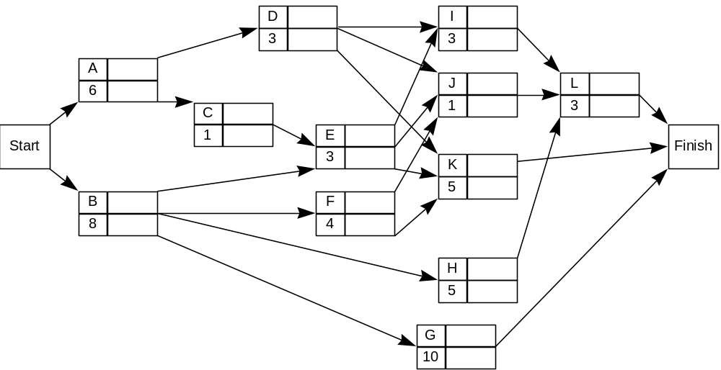

a) Prepare a table of the earliest and latest start and finish times and slack times for each activity in Bonanza's project.

b) What is the critical path and the expected project completion time?

c) Reliable Plumbers, the subcontractor performing activity J, is going to be delayed 5 weeks. If the project is delayed, it will cost Bonanza $2000 per week of delay of the entire project. Reliable is charging $3000 for the plumbing.

Bonanza has three options:

(1) Keep Reliable Plumbers.
(2) Cancel the contract with Reliable Plumbers and hire Local Plumbers, Inc. Local
Plumbers, however, will take two weeks to do activity J, and will charge $7000.
(3) Bonanza can train its own employees who are currently performing activity E to
do the work. This involves a two-week training period as soon as activity E is
done. Then it is expected it will take them three weeks to perform activity J.
The cost of the training is $800 per week and the cost of them doing activity J is
$1,000 per week.

Which alternative do you recommend to Bonanza? Explain.

PROBLEM 10

Consider the following PERT network with estimated times in weeks. The project is scheduled to begin on May 1.

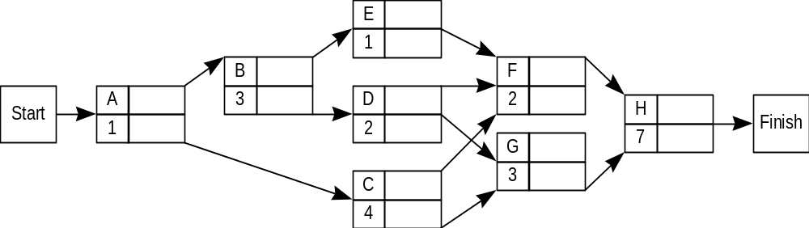

The three-time estimate approach was used to calculate the expected times and the following table gives the variance for each activity:

Activity Variance Activity Variance
A 1.1 E .3
B .5 F .6
C 1.2 G .6
D .8 H 1.0

a) Give the expected project completion date and the critical path.

b) By what date are you 99% sure the project will be completed?

c) The project has a target completion date of August 28 (17 weeks). If the project is completed by August 28, the profit on the project will be $10,000. If work is not completed by August 28, a $5,000 penalty will be incurred, reducing the project's profit to $5,000. For $2,000 more than is currently being spent for a firm to do activity H, a more experienced firm can complete the activity in just 5 weeks. Should this offer be accepted? (Assume the variance for H will not change.)

PROBLEM 11

Consider the following PERT network.

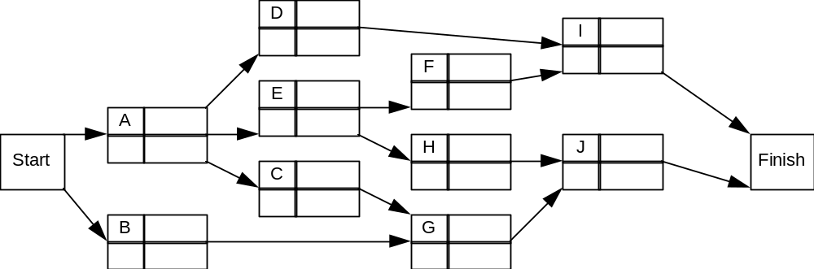

The following chart has been prepared giving the optimistic time (a), the most likely time (m), and the pessimistic time (b), in weeks for each activity.

Activity a m b Activity a m b
A 2 8 14 F 2 3 10
B 3 12 21 G 3 9 15
C 2 5 8 H 7 8 9
D 4 5 12 I 3 11 13
E 1 3 17 J 7 10 13

a) Determine the critical path, expected project completion time, and standard deviation of the project completion time.

b) Management insists that the project be completed in 36 weeks and will be charged a $100,000 fine for any time overrun. If, at a cost of $3,000, the expected completion time of activity A could be reduced by 2 weeks, should the extra money be spent? (Assume A's variance does not change.)

c) Why is considering only critical path activities for project completion time not always a good assumption in probabilistic cases? (HINT: Consider activity E.)
PROBLEM 12

Plane, Inc. is a manufacturer of heavy equipment and is considering introducing a new line of small steamrollers. Development is to proceed as follows.
A feasibility study will first be performed. Upon receiving a successful feasibility report, a manufacturing building is to be secured and a project leader hired. Once the building is secured, Plane will be committed to the project. Therefore an advertising group will be selected and the raw materials for the manufacturing process will be purchased. When, in addition to securing the building, a project leader has been named, a manufacturing staff will be recruited.
After the manufacturing staff has been selected and the raw materials purchased, a prototype model of the steamroller will be produced. Following the completion of the prototype, work will begin on a production run of 100 steamrollers. When both the prototype model has been built and the advertising staff selected, an intensive advertising campaign will be launched.
The development phase of this project will be complete with the production of the first 100 steamrollers and the initiation of the advertising campaign.
Two separate cost analyses have been prepared. One is effective under current (normal) conditions, while the other is effective if the development phase of the activities is "crashed". These are summarized below. (Times are in weeks.)

Normal Crash
Activity Time Cost Time Cost
Feasibility Study (A) 6 $ 80,000 5 $100,000
Building Purchased (B) 4 100,000 4 100,000
Project Leader Hired (C) 3 50,000 2 100,000
Advertising Staff Selected (D) 6 150,000 3 300,000
Materials Purchased (E) 3 180,000 2 250,000
Manufacturing Staff Hired (F) 10 300,000 7 480,000
Prototype Manufactured (G) 2 100,000 2 100,000
Production Run of 100 (H) 6 450,000 5 800,000
Advertising Campaign (I) 8 350,000 4 650,000

a) Draw the PERT network for this problem.

b) Formulate and solve a linear program for determining the minimum cost of completing this project in half a year (=26 weeks).

c) What assumptions are made in calculating the "marginal" costs for the activities?

- Interpret the meaning of the shadow price that would be associated with the constraint that set the maximum completion time to 26 weeks.

PROBLEM 13

Joseph King has ambitions to be mayor of Williston, North Dakota. Joe has determined the breakdown of the steps to the nomination and has estimated normal and crash costs and times for the campaign as follows (times are in weeks):

Normal Crash Immediate
Activity Time Cost Time Cost Predecessors

A. Solicit Volunteers 6 $5,000 4 $ 9,000 ----

B. Initial "Free"
Exposure 3 $4,000 3 $ 4,000 ----

C. Raise Money 9 $4,000 6 $10,000 A

D. Organize and Co-
ordinate Schedule 4 $1,000 2 $ 2,000 A

E. Hire Advertising
Firm 2 $1,500 1 $ 2,000 B

F. Arrange Major
TV Interview 3 $4,000 1 $ 8,000 B

G. Advertising
Campaign 5 $7,000 4 $12,000 C,E

H. Personal
Campaigning 7 $8,000 5 $20,000 D,F

a) Joe King is not a wealthy man and would like to organize a four month (16 week) campaign at minimum cost. Write and solve a linear program to accomplish this task.

b) Dan Wetzel is an independent who is also trying to make a bid to become mayor of Williston. He has promised a clean campaign, one that he will initially finance on his own. He has $50,000 to invest in his campaign. Being a student of recent successful political campaigns, he knows that his best chance to win is be a "fresh new face" at nomination time. Hence he wishes to keep the entire campaign from beginning to end at a minimum. Write a linear program that, when solved, will minimize the total time of the campaign while keeping expenditures to a maximum of $50,000.

PROBLEM 14

For the project represented below, determine the earliest and latest start and finish times for each activity as well as the expected overall completion time.

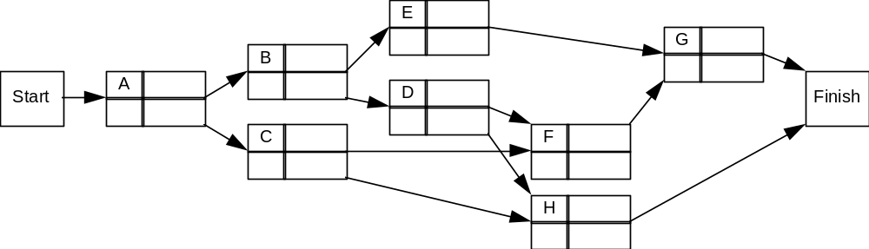

Activity Time ES EF LS LF Slack
A 4
B 3
C 4
D 2
E 5
F 2
G 5
H 6

TRUE/FALSE

___ 15. All activities on a critical path have zero slack time.

___ 16. In PERT, it is assumed that the amount of time to complete any one activity is independent of the amount of time to complete any other activity in the project.

___ 17. In PERT, an activity's most probable time is the same as its expected time.

___ 18. In PERT, it is assumed that the underlying distribution for each activity in the three-time estimate approach is a normal distribution.

___ 19. In a given PERT problem, activities F and G are on the critical path. If each is delayed two weeks, then in all cases, the project will be delayed four weeks.

___ 20. The difference between an activity's earliest finish and latest finish equals the difference between its earliest start and latest start.

___ 21. In a given PERT problem, activities F and G are not on the critical path and each has two weeks slack time. If both are delayed by two weeks each, then in all cases, the project will not be delayed.

___ 22. An activity can be started as soon as any one of the activities that immediately precedes it is finished.

___ 23. In a given PERT problem, activity F is on the critical path. If its time is reduced by five weeks, then in all cases, the overall project completion time will be reduced by five weeks.

___ 24. In PERT, the critical path is the path of longest distance through the network.

___ 25. In CPM, the marginal cost per week’s saving of an activity’s completion time is valid only between its normal time and the time after maximum crashing.

___ 26. It is possible to have more than one critical path at a time.

___ 27. In CPM, if activity B’s normal completion time is 8 weeks and normal cost is $10,000, and its completion time after maximum crashing is 5 weeks at a cost of $15,000, then the assumption is that if $13,000 is spent on activity B, its completion time is 6.8 weeks.

___ 28. The project manager should monitor the progress of any activity with a large variance even if the expected times do not identify the activity as a critical activity.

___ 29. A critical activity can be part of a noncritical path.

